**Assignment -3**

Digital Marketing

|  |  |
| --- | --- |
| Student Name : | Rovan M |
| Student Roll Number : | 20URCS039 |
| NM ID : | 7032B9600E7406FA64A4010364C46BA8 |
| College Name : | AAA College of Engineering and Technology |

**QUESTION:**

**Create and design a social media advertisement poster using canva.**

**SOCIAL MEDIA ADVERTISEMENT POSTER USING CANVA:**

**Poster link:** [**https://crazyzone2k23.blogspot.com/2023/09/crazyzone.html**](https://crazyzone2k23.blogspot.com/2023/09/crazyzone.html)

**Poster Title: Crazy Zone**

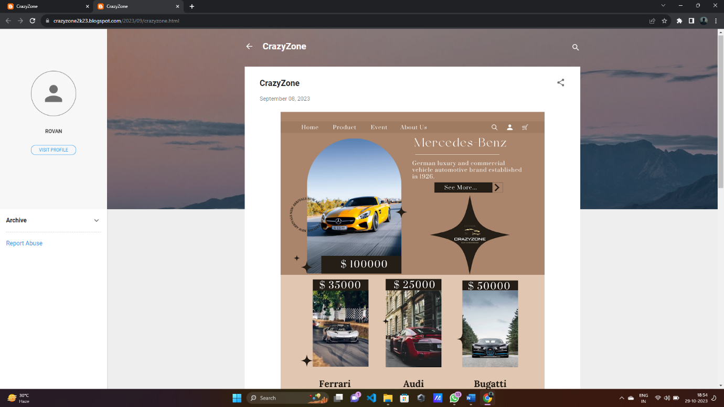

**Poster :**

